


Sunway
Diploma
Studies

IT Project Proposal

Currency Converter with
Extra Features

by

Ivan Wong Onn Yee
Woo Chan Ee

Diploma in Information Technology

Supervisor: Mr Siwa Kumaran Thannimalai

(Date of submission)8

Abstract
Project title | : Currency Converter with Extra Features
Student | : Ivan Wong Onn Yee, Woo Chan Ee
Supervisor | : Mr Siwa Kumaran Thannimalai

Abstract
This proposal explains about the website “currency converter with extra features” that our group is planning to create for this IT project. The website we are creating is a currency converter website packed with extra features specifically tailored to travellers and forex enthusiasts.To do this, we are adding and implementing features such as forex charts, hyperlinks, calculators, time zone converter etc. We plan to conduct an online survey to collect information on the current requirements or standards that the market expects from our website. We envision travellers using our website to do all the necessary research and calculations and using our provided hyperlinks to make the necessary arrangements for their travels. Forex traders can also view our charts and do their calculations with our in-built calculator. We have prepared a Gantt Chart showing the progress and timeline of our development process and future plans we hope to achieve. To ensure a smooth development process, we have listed down five potential risks and problems we might encounter and also listed down our plan to alleviate these problems.

Table of Contents (ToC)

Table of Contents
1.0 Introduction 3
2.0 Problem Statement and Literature Review 4
2.1 Problem Statement 4
2.2 Literature Review 4
3.0 Objective 6
4.0 Scope of work 6
5.0 Methodology 6
5.1 Online Survey Questionnaire 8
6.0 Projected Outcome and Timeline 9
7.0 Risk Management 10
8.0 References 11

1.0 Introduction
As technology continues to develop and grow, the demand for travelling also increases. (Vidal, B. 2019, https://www.wearemarketing.com). Figure 1.0 shows that in the year 1990, there were 439.4 million arrivals in the five continents listed in the chart which are Africa, Middle East, Asia & Pacific, Americas, and Europe. This number has grown to 1.4 billion arrivals in a mere 18-year thanks in part to the technological boom in recent times.

The most famous time zone and currency converter websites in Asia are such as https://www.thetimezoneconverter.com , a time zone converter website and https://www.xe.com , a currency converter website. Users will need to have a stable internet connection to do the appropriate research before deciding on a location to travel.
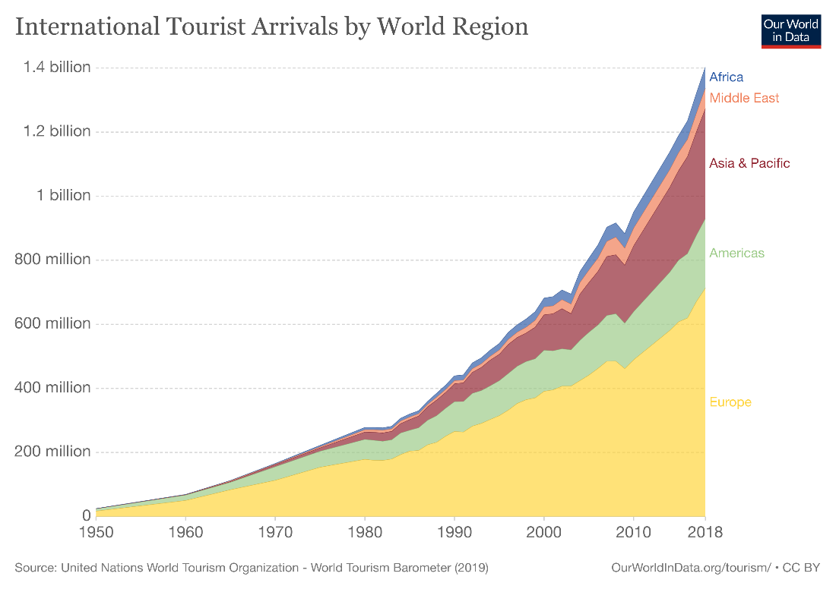`
Figure 1.0

Our travel and currency converter website is created to cater to all travellers or to those who are simply curious on currency and time zone conversion. This website will feature 7 pages which are the homepage, charts page, time zone page, tools page, hyperlinking page, about page and the language page. The transition between all the pages will be seamless and the tools page will offer multiple tools such as a calculator tool, calendar tool and a map tool.

2.0 Problem Statement and Literature Review

2.1 Problem Statement
- Language proficiency issues. According to Ethnologue, there are approximately 7,139 languages being spoken today which does not include dialects. Therefore, language barriers are prevalent in society, this also applies for websites. For example, some people with have poor language proficiency skills will not be able to understand the content provided on other websites. According to our website, we target that Malaysian provided more than one language such as international language (English), Chinese simplified language and Malay language so that people will be easily to understand our website content.

- Too hard to find money exchange shop. Usually, people will use local money when in another country and there are often some people who have not to prepare enough money to travel. In addition, it is difficult for tourists who do not know that local area to find a money exchange shop. Using our website have provided google map so that tourists will easily find a money exchange shop in a short time.

- Too much research has to be done by travelling. Nowadays, with the influx of new technological developments, there are a plethora of websites which offers tools to help travellers decide and research on their destination spot. For example, xe.com is a currency conversion website which helps people understand the conversion of their native currency into another's and thetimezoneconverter.com is a time zone conversion website which helps people understand the differences between the time zone they are in and they time zone they will be travelling to. Therefore, when someone is doing research for his or her vacation, they must open multiple tabs and windows to look for different information. This is caused by a lack of an all-in-one-travel website that encompasses all the research to be done. Because of this, people have to sit through mind-numbing research through multiple websites.

2.2 Literature Review

A) Definition
Currency conversion is defined as the knowledge of the real value of one’s currency to be converted into another country’s currency so that an individual can understand the difference in value of the currencies to ease their struggles when they are researching for their travels.

Travelling is the action or activity of going from one place to another that typically requires a great distance. It is usually done using an aeroplane or by a boat. There are also many types of travelling such as business travel and family travel. Business travel is when an individual travels for the purpose of attending to business located in a far location. Family travel is when an individual brings his or her family for a vacation typically in a foreign country.

How it works
Users will be greeted to our home page and will be given two currencies to convert. After they have converted the currency. They can view the movement of prices of different currencies in different pages and view the time zone of all countries. They can also use the calculator and calendar tool on our website to help customers with their planning. Users can also book tickets and hotels. With our more page, users can book flight and hotel tickets with our hyperlinks situated in the more page.

Benefits
Currency conversion is essential when travelling as the local currency we use in our country cannot be used in a foreign country. For example, the Malaysian currency MYR cannot be used in the United States of America as their currency is USD. Because of this, we have to convert our currency MYR to USD when we travel to the United States of America. We can convert our currency by going to money changers and banks. Before converting currency, users can refer to our website to check the real time conversion rate so that they do not get scammed with a more expensive rate.

As we live in a busy environment, time is of upmost importance. Our website is designed with convenience in mind to save all travellers and curious individuals some time as they start to research and plan on our website. As our website offers multiple tools such as a calculator, calendar, currency price chart and hyperlinks to flight and hotel booking websites which are all a click away, users can save time by doing their whole planning and researching on one website.

Our website compared to others
Name | Features | Fee
Currency Converter with extra features | Currency Conversion, Chart, Hyperlink to hotel booking and flight booking, Calculator, Calendar, Time Zone, Language Conversion | 0$
Oanda | Currency Conversion, Money Transfer, Forex Trading | 0$
XE | Currency Conversion, Chart, Money Transfer, Rate tracker to notify users of a certain price | 0$
convertmymoney | Currency Conversion, Rate tracker to notify users of a certain price | 0$

B) Technology
Our website is built and designed from the ground up using these technological tools
Operating System | macOS, Microsoft Windows
Database | MySQL
Programming Language | PHP, HTML, Java, Javascript
Software | Adobe Photoshop

3.0 Objective
To build and design a webpage that can help travellers plan and organize their travels, we will build and implement additional features like our calculator, calendar, a time zone page and hyperlinks to book flight tickets and hotels. Users using our website can convert their local currency, then proceed to our time zone to check the time in the country he or she is planning to travel to. After that, they can plan the dates using our calendar tool and finally book tickets with our provided hyperlinks.

To provide a plethora of languages to satisfy most consumers from all around the world. As we are releasing our website worldwide, we will face traffic from many countries with different mother tongues. To make sure all users are satisfied with the experience, we are releasing a feature to convert our website into many different languages. With this feature, users from all around the world can enjoy surfing our website with the language they are most comfortable with.

To provide forex traders with live charts of currency conversion. As we want our target audience to be as broad as possible, we want to satisfy as many people’s needs as we can. A certain demographic we are targeting are forex traders. Forex trading is the process of trading of currencies for financial gain. Forex traders can use our website and visit our charts page for real time charts of currencies. They can refer to the charts that are provided by our website and plan on their next trade.

4.0 Scope of work
Our currency converter software will have the following scope:
- Our software cannot make a video and audio call since our currency converter website is only for exchange money.
- Our software allows GPS function and customers can use Google maps to finds money exchange shops.
- Our software allows a customer to change 3 languages (English, Malay, Chinese) and easy to know that our website.
- Our software also allows customers to use the calculator to calculate and make notes on the calendar.
- Currency convert money allows 33 different countries (USA, UK, CHN, MYS, SGD, etc).
- Booking hotel ticket only allows hyperlink function to provide customers with more activity.
- Time Zone convert only allows 4 different countries.

5.0 Methodology
For this project, we are adopting Rapid Application Development (RAD). Rapid Application Development (RAD) is a development methodology that emphasizes the fabrication process and evaluation over lengthy development and testing cycles. Rapid Application Development allows developers to make numerous iterations and modifications to programs without having to restart the developing process from the beginning each time. While RAD has evolved throughout time, these four fundamental phases have remained consistent such as Define the requirements, Prototype, Receive Feedback and Finalize Software. (Figure 5.0)

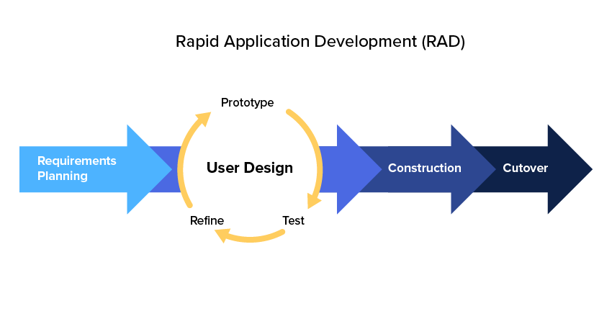
Figure 5.0

Advantages of Rapid Application Development (RAD).
Advantage | Description
Measurable Development  &  Decrease Progress Time | It is considerably simpler to evaluate progress and manage timelines and budgets due to the natural process of frequent iterations, prototyping, and components. As a result, organizations benefit from a faster delivery or faster adoption inside the organization, which helps them achieve their objectives.
Easily Modifying | The RAD iterative procedure is structured in such a way that developers must build operationally independent components that will form the final application. Although each component is segregated, it can be readily updated to match the software's growing demands, resulting in a slew of individual and collective benefits in terms of performance, budget, and software development time.
Cost | In rapid application development, developers create just the systems that the customer demands. In a waterfall project, IT runs the risk of creating and branching out complicated evaluation metrics that the user may decide to remove from the result. RAD programming lowers the risk, and decreases the cost.

5.1 Online Survey Questionnaire
For our project, we are doing online survey to collect all the data and customer feedback.
Method Used | Online survey form
Target Subject | Target more than 20 customer
Distribution Method | Google Forms and Email
Duration Of Research | To collect data in 2 weeks

Sample question to collect customer data and feedback:
- What is your age? 17 and below, 18-23, 24-35, 36 and above
- Gender M/F
- Ethnicity (Chinese, Indian, Malay, Other)
- Are you a frequent traveller?
- Do you agree that doing research for travelling is too cumbersome? (Eg. Finding out the time zone, converting currency)
- Do you agree that the aforementioned process should be reformed?
- Do you think that there should be a website that encapsulates all research required into one single website?
- Do you dabble in forex trading?
- If yes, would it be helpful to include forex chart functionality in currency converters
- Do you think that multi-language support for websites is an important feature?
- Do you think built-in tools such as calculators and calendars in websites are useful?

6.0 Projected Outcome and Timeline

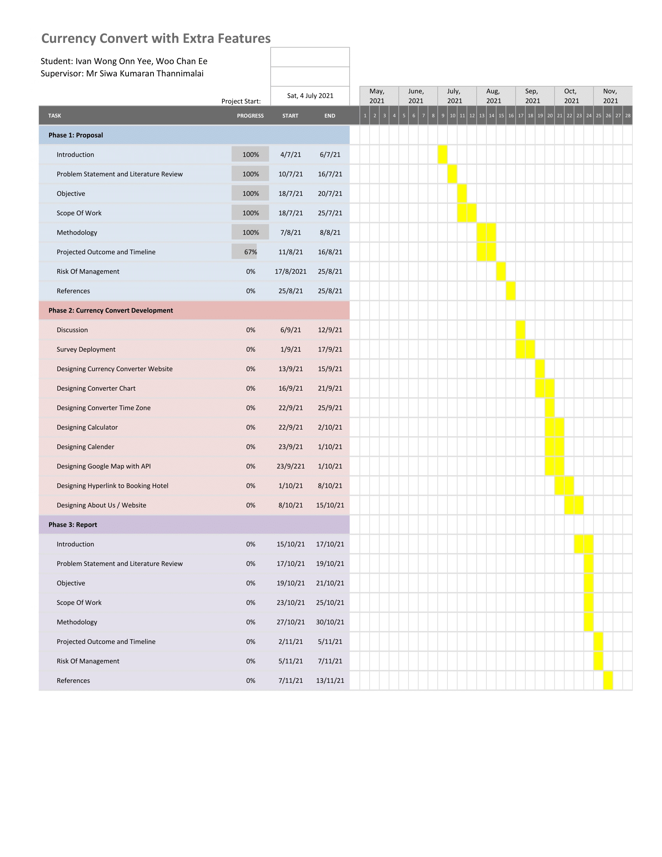

7.0 Risk Management

Risk | Risk Level | Mitigation/ Solution
Language proficiency issues | Low levels | Our currency converter website setting provides 3 different languages so that customer easily understands.
Database collect will be delay | Low levels | Although sometimes database collected will be delay, but the data will be automatic saving in MySQL.
Hyperlink malfunction | Medium levels | To solve this problem, our team only selected official third-party website to give a customer better experience.
Mobile Incompatibility | Medium levels | To solve this problem, we implemented additional CSS codes to fit the size of mobile phones.
Inaccuracy of conversion | High levels | Due to inflation, sometimes the conversion will be +$1.5 or -$1.5 inaccurate. To reduce this problem, our team uses the National Conversion API to ensure conversion to +$0.5 or -$0.5.
* Risk levels include Low Level, Medium Level, and High Level

8.0 References

FNTS Blog, (September 6, 2017). 5 Competitive Advantages of Rapid Application Development. Retrieved from: https://info.fnts.com/blog/5-competitive-advantages-of-rapid-application-development

Stanley Idesis, (October 9, 2020). Rapid Application Development: Why RAD and Why Now. Retrieved from: https://www.outsystems.com/blog/posts/rapid-application-development/

Ethnologue, (February 22, 2021). How many languages are there in the world? Retrieved from: https://www.ethnologue.com/guides/how-many-languages

Unwto, (January 21, 2019). INTERNATIONAL TOURIST ARRIVALS REACH 1.4 BILLION TWO YEARS AHEAD OF FORECASTS. Retrieved from: https://www.unwto.org/global/press-release/2019-01-21/international-tourist-arrivals-reach-14-billion-two-years-ahead-forecasts

Vidal, B. (2019). The New Technology and Travel Revolution. Retrieved from: https://www.wearemarketing.com/blog/tourism-and-technology-how-tech-is-revolutionizing-travel.html https://www.wearemarketing.com/blog/tourism-and-technology-how-tech-is-revolutionizing-travel.html

